**DESIGNING A BYTE-ENABLE MEMORY IN VERILOG AND SYSTEM-VERILOG**

**Submitted**

**By**

**1. Mr. Tammali Karthik BU21EECE0100164**

**2. Ms. Maria Punya BU21EECE0100309**

**3. Mr. P Visweswara Rao BU21EECE0100086**

**Under the Guidance of**

**Dr M Arun Kumar**

**Associate Professor**

**(Duration: 31-July-2024 to 18-october-2024)**



**Department of Electrical, Electronics and Communication Engineering**

**GITAM School of Technology**

**GITAM**

**(DEEMED TO BE UNIVERSITY)**

**(Estd. u/s 3 of the UGC act 1956)**

**NH 207, Nagadenehalli, Doddaballapur taluk, Bengaluru-561203 Karnataka, INDIA.**

**DECLARATION**

**I/We declare that the project work contained in this report is original and it has been done by me under the guidance of my project guide.**

**Date:**

|  |  |  |  |
| --- | --- | --- | --- |
| **S,No** | **Reg,No** | **Name of the Student** | **Signature** |
| **01** | **BU21EECE0100309** | **Maria Punya** |  |
| **02** | **BU21EECE0100164** | **Tammali Karthik** |  |
| **03** | **BU21EECE0100086** | **P.Visweswara Rao** |  |

**Department of Electrical, Electronics and Communication Engineering GITAM School of Technology, Bengaluru-561203**



**CERTIFICATE**

This is to certify that Maria Punya (BU21EECE0100309), Tammali Karthik (BU21EECE0100164), P.Visweswara Rao (BU21EECE0100086) bearing has satisfactorily completed Mini Project Entitled **“Designing a byte-enable memory in verilog and System Verilog”** in partial fulfillment of the requirements as prescribed by University for VII semester, Bachelor of Technology in “Electrical, Electronics and Communication Engineering” and submitted this report during the academic year 2024-2025.

**Signature of the Guide Signature of HOD**

**Dr. Arun Kumar M Dr. Prithvi Sekhar Pagala**

|  |  |  |  |  |  |
| --- | --- | --- | --- | --- | --- |
| **CONTENTS**  **NAME Page No** | | | | | |
| **Chapter 1** | | **INTRODUCTION** | | **05** |
| **1.1** | | **Overview of the problem statement.** | **05** | |
| **1.2** | | **Objectives and goals** | **06** | |
| **Chapter 2** | **Literature Review** | | **07** | |
| **Chapter 3** | **Strategic Analysis and Problem Definition** | | | |
| **3.1** | | **SWOT Analysis** | **09** | |
| **3.2** | | **Project Plan- GANTT Chart** | **10** | |
| **3.3** | | **Refinement of problem statement** | **10** | |
| **Chapter 4** | | **Methodology** | **11** | |
| **4.1** | | **Description of the approach** | **11** | |
| **4.2** | | **Tools and technoques utilized** | **12** | |
| **4.3** | | **Design Consederations** | **13** | |
| **Chapter 5** | | **Implementation** | **15** | |
| **5.1** | | **Description pf how the project was executed** | **15** | |
| **5.2** | | **Challenges faced and solutions implemented.** | **17** | |
| **Chapter 6** | | **Results** | **18** | |
| **6.1** | | **Outcomes** | **18** | |
| **6.2** | | **Interpretation of results** | **19** | |
| **6.3** | | **Comparison with existing literature or technologies** | **19** | |
| **Chapter 7** | | **Conclusion** | **20** | |
| **Chapter 8** | | **Future Work** | **21** | |
|  | | **References** | **22** | |

**ABSTRACT**

Designing a byte-enable memory in verilog and system verilog involves creating a memory module that allows for selective enabling of individual bytes within a wider data word during read and write operations. This functionality is crucial in systems where precise control over memory access and modification is needed, such as in embedded systems, processors, and digital signal processing applications. Byte-enable memory modules are essential components in digital systems, enabling fine-grained control over memory operations. It prevents the implementation of a byteenable memory module using both verilog and system verilog. This optimizes memory usage and enhances performance in various applications, including embedded systems and data-intensive computing tasks. Mostly all embedded memory blocks that are implemented as rams support byte enables that mask the input data for specific bytes, nibbles, or bits of data. This process begins with defining the memory's architecture, including parameters such as word size, memory depth, and the number of bytes enabled. In verilog, the implementation involves creating a memory array and developing logic for handling byte-enable signals during read and write operations. It writes logic ensures that only the selected bytes are modified, while the read logic provides the correct data bytes based on the enable signals. In this proposed system, system verilog extends its capabilities by introducing advanced features such as type definitions, enumerations, and packed structures, which facilitate more efficient and readable code. The implementation in system verilog takes advantage of these features to streamline the design process, enhance code maintainability, and will improve simulation and byte-enable memory access efficiency, reduces power consumption, and enhances the flexibility of data handling in various computing systems.

**Fig:- Random Access Memory(RAM) Background**

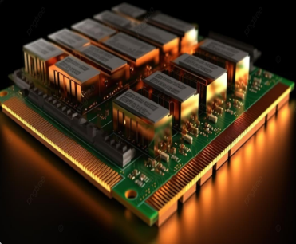

# **Chapter 1**

# **Introduction**

In today's complex digital systems, precise control over memory access and modification is essential for efficient and optimized operation. This is particularly true in applications such as embedded systems, processors, and digital signal processing, where data-intensive tasks are common. Byte-enable memory modules address this need by providing granular control over individual bytes within a wider data word during read and write operations.

Byte-enable memory modules are crucial components that enable selective byte-level manipulation in memory operations. These modules are often implemented in embedded memory blocks, such as RAMs, which support byte enables to mask input data for specific bytes, nibbles, or bits. This flexibility is invaluable in scenarios where only a portion of the data word needs to be modified or accessed.

The design process for a byte-enable memory module involves carefully considering several key factors. The memory's architecture must be defined, including parameters such as word size, memory depth, and the number of bytes enabled. Verilog, a hardware description language, is commonly used to create the memory array and develop the logic that handles byte-enable signals during read and write operations. This logic ensures that only selected bytes are modified and that the correct data is provided based on the enable signals.

## **1.1 Overview of the problem statement**

Designing a byte-enable memory using Verilog and SystemVerilog involves creating a memory module that allows selective access to specific bytes within a larger data word. This is essential in systems where data width is greater than the bus width, enabling efficient data manipulation without accessing or modifying entire words. The byte-enable feature is implemented using control signals that specify which bytes in the word are active during read or write operations, allowing for more flexible and optimized memory usage. The challenge lies in ensuring that the design is both efficient and compliant with timing and resource constraints, while also being scalable and adaptable to different memory sizes and configurations.

## 

## **1.2 Objectives and goals:**

The objective of this project are

* To design and implement a byte-enable memory module using Verilog and System Verilog, optimizing memory usage by allowing selective access and modification of specific bytes within a larger word.
* To enhance data integrity, performance, and scalability in digital systems by providing a versatile and efficient memory access interface, ensuring robust control mechanisms and minimal latency.
* To contribute a comprehensive testing and validation framework using Verilog and System Verilog.

Main Goals:

* Implementing the byte-enable feature in memory design aims to create a scalable and reusable module that can be easily integrated into various digital systems.
* Create a flexible design adaptable to different systems.
* Ensure reliable functionality through thorough testing and validation.

# **Chapter 2**

# **Literature Review**

We have discussed several projects related to Byte-enable RAM. Each of these projects comes with its unique set of challenges and considerations. Here is a brief overview and some comments on each of them:

* Advancing cryptographic security: a novel hybrid AES-RSA model with byte-level tokenization.
* **Technology:**
* Byte-Pair Encoding (BPE) tokenizer for data obscuration.
* Dual-layer encryption using RSA and AES.
* **Advantages:**
* Enhances data security by using a combination of tokenization and multi-layer encryption.
* **Research Gap:**
* Increased computational overhead due to the use of multiple encryption layers.
* Complexity in key management and synchronization across the two encryption layers.
* Design and Implementation of Memory Controller for Byte Access from Data Memory for SoC's Devices.
* **Technology:**
* Bit-optimized Non-Volatile Memory (BNVM) with reduced bit flipping.
* **Advantages:**
* Achieved up to 3.56× reduction in bit flips, extending memory lifespan.
* Minimal impact on performance while optimizing memory write operations.
* **Research Gap:**
* Some optimized approaches increased bit flips despite reducing overall write operations.
* Needs further exploration on scalability and performance in larger, more complex systems.
* Optimizing Systems for Byte-Addressable NVM by Reducing Bit Flipping
* **Technology:**
* Memory controller for System-on-Chip (SoC) architectures.
* Uses the AXI (Advanced eXtensible Interface) protocol for parallel communication.
* **Advantages:**
* Improves data transfer speed and reduces the processor workload in SoC systems.
* **Research Gap:**
* Challenges in optimizing the controller for different SoC configurations and workloads.
* Needs more efficient handling of data transfer bottlenecks for higher-performance systems.
* 20nm High-density single-port and dual-port SRAMa with worldline-voltage-adjustments system for read/write assists.
* **Technology:**
* Byte-level tokenization using Byte-Pair Encoding (BPE).
* Dual encryption layers with RSA and AES algorithms.
* **Advantages:**
* Strengthens data security with two encryption layers, providing enhanced protection.
* Byte-level tokenization offers fine-grained control over data security.
* **Research Gap:**
* Similar to [1], this method increases computational complexity and overhead.
* A 45-nm Single-port and Dual-port SRAM family with Robust Read/Write Stabilizing Circuitry under DVFS Environment.
* **Technology:**
* SRAM macros using wordline-voltage suppression and negative bitline techniques.
* Fabrication in 45-nm CMOS technology for Dynamic Voltage and Frequency Scaling (DVFS).
* **Advantages:**
* Enhances read stability and write margins over a wide voltage range (0.7 V to 1.3 V).
* Ensures robust performance in low-power and high-performance systems.
* **Research Gap:**
* Increased complexity in designing and implementing negative bitline techniques.

# **Chapter 3 Strategic Analysis and Problem Definition.**

**Strategic Analysis:**

Designing a byte-enable memory with Verilog and System Verilog offers improved memory efficiency and control, but faces challenges in implementation complexity and compatibility. Opportunities include advanced memory solutions and innovation, while adoption hurdles and competition pose threats.

**Problem Definition:**

The challenge is to create a byte-enable memory system that effectively balances data access efficiency and integration ease, addressing implementation complexity and compatibility issues to ensure successful industry adoption.

## **3.1 SWOT Analysis:**

**Strengths**

**Weaknesses**

**W1**. **Complexity:** Designing byte-enable memory is challenging.

**W2**. **Debugging Difficulty:** Hardware debugging is tough.

**S1.** **Flexibility:** SystemVerilog offers advanced features.

**S2.** **Industry Relevance**: Verilog and SystemVerilog are widely used in the hardware design industry, making skills in these languages highly valuable.

### 

**Opportunities**

**01.** **Optimization**: There is a significant opportunity to optimize memory usage, power consumption, and performance by designing efficient byte-enable memory.

**02.** **Customization:** Tailor designs for specific applications.

**O3**. **Advancements in Verification:** Use advanced verification features.

**04.** **Career Advancement**:: Expertise in Verilog and SystemVerilog can open doors to advanced roles in hardware design, verification, and EDA tool development.

**T1**. **Evolving Standards:** Continuous need to adapt to new methodologies.

**T2.**  **Competition:** Pressure to deliver efficient designs quickly.

**Threats**

### **3.2 Project Plan - GANTT Chart**

**Contents of Project Plan**

|  |  |  |  |
| --- | --- | --- | --- |
| SL.NO | Start Date | End Date | Description |
| 1 | 23-july-2024 | 24-july-2024 | Gathering research papers and understanding the problem statement |
| 2 | 31-july-2024 | 19-july-2024 | Abstract & Research for the project. |
| 3 | 22-july-2024 | 26-july-2024 | Workflow of the project. |
| 4 | 26-july-2024 | 30-july-2024 | Review-1 |
| 5 | 07-oct-2024 | 16-oct-2024 | Exploring the other concepts of the Project. |
| 6 | 17-oct-2024 | 18-oct-2024 | Review-2 |

##### **3.3 Refinement of problem statement**

Designing a byte-enable memory using Verilog and System Verilog involves creating a memory system capable of selectively enabling data access at the byte level, optimizing both performance and memory utilization. The primary challenge is to develop a robust and efficient design that minimizes implementation complexity while ensuring compatibility with existing systems. This includes managing the intricacies of hardware description languages and addressing potential issues such as timing constraints, signal integrity, and integration with various memory architectures. The solution must also consider scalability and adaptability to different application needs. Ensuring that the final design meets industry standards and performs reliably across different conditions is crucial for its successful adoption and practical use in advanced electronic systems.

# 

# **Chapter 4**

# **Methodology**

**4.1 Description of the Approach**

Designing a byte-enable memory using Verilog and SystemVerilog involves creating a memory module capable of selectively reading or writing individual bytes within a larger data word. This design approach is crucial for systems where the data width exceeds the bus width, providing efficient and flexible data manipulation. The goal is to allow access to specific bytes without affecting the entire data word, which is important in applications like data processing, microcontrollers, and embedded systems.  
Phase 1: Implementation of Single port RAM in Verilog using Xilinx Vivado.

* Single-Port RAM is a memory module that allows access to only one memory location (either read or write) at a time through a single address and data bus.
* Implementing the Verilog code in the Xilinx Vivado.
* Specifications: Set data width, byte width, memory depth, and byte-enable width.
* Design Memory Array: Declare a 2D memory array based on data width and depth.
* Implement Write Operation: Update memory selectively based on byte enable and write enable signals.
* Implement Read Operation: Add synchronous read logic to fetch data from memory.
* Testing and Simulation: Verify functionality with a testbench for various write and read cases.
* Synthesis and Optimization: Synthesize and optimize the design for timing and resource constraints.
* Results are considered for further understanding of the problem statement and implement in the different applications.

**Design of Single-Port RAM**

In the design of single-port RAM, the memory operates with a single set of address, data input, and data output lines, meaning it can only perform either a read or a write operation during a given clock cycle, but not both simultaneously. The memory array is structured using a 2D data arrangement to efficiently store and retrieve data. A clock signal synchronizes these operations, while a write enable (WE) signal controls whether data is written into the memory or read from it. This design is simpler and consumes less power compared to dual-port RAM, making it ideal for applications like embedded systems and data buffers where simultaneous operations are not required, though it may limit performance in more demanding environments.

### **4.2 Tools and techniques utilized**

In constructing the Single-Port RAM, Verilog was the primary hardware description language used to describe the memory array, control logic, and read-write operations. Verilog enabled precise control over the low-level design, making it possible to define fundamental digital components such as logic gates, flip-flops, and memory blocks within the single-port RAM structure. RTL (Register Transfer Level) simulation, based on Verilog, allowed for early functional validation of the design before the synthesis phase.

Tools like Xilinx Vivado, or equivalent FPGA development platforms, played a crucial role in both the simulation and synthesis stages. RTL verification was conducted to detect functional errors early in the design process, ensuring smooth development. Key features like timing analysis, resource utilization reports, and bitstream generation helped optimize the design to meet hardware constraints. Additionally, Vivado facilitated the use of test benches, allowing for thorough testing of the single-port RAM's functionality, leading to a reliable and efficient hardware implementation.

#### **4.3 Design considerations**

**4.3.1 Sequential Access and Synchronization**

In Single-Port RAM, memory access is handled sequentially as only one read or write operation can occur at a time. Since the memory has only one set of address, data, and control lines, it cannot perform simultaneous operations like Dual-Port RAM. This constraint makes it suitable for applications with lower performance requirements but where simplicity and reduced resource consumption are preferred. Synchronization with the system clock ensures that each memory operation is executed at the correct timing, reducing the risk of data corruption and ensuring reliable performance. The clock synchronization is especially important in Single-Port RAM as it guarantees that memory access operations are executed in the correct sequence, preventing issues such as timing mismatches that can lead to incorrect data being written or read.

**4.3.2 Conflict-Free Operation**

Unlike Dual-Port RAM, Single-Port RAM does not face the issue of concurrent accesses since only one operation can occur per clock cycle. However, if multiple operations need to occur in a very short period, the system must wait for each operation to complete before the next begins. This limitation introduces latency in applications that require high-speed data access. Nonetheless, conflict resolution mechanisms are not needed in Single-Port RAM, making it simpler and more efficient for applications where the likelihood of simultaneous read/write operations is low.

**4.3.3 Optimal Resource Utilization**

Single-Port RAM offers an efficient design in terms of hardware resource usage. Since only one set of control signals and data paths is needed, it uses fewer logic gates, memory cells, and registers than Dual-Port RAM. This makes it particularly suitable for FPGA-based designs where conserving resources is essential. The simplicity of Single-Port RAM allows for easy optimization using techniques like clock gating and selective logic synthesis, which reduce power consumption by disabling unused portions of the memory when not in use. These optimizations are beneficial in reducing power dissipation and improving system reliability, especially in low-power applications like embedded systems.

**4.3.4 Scalability and Portability**

Single-Port RAM is also highly scalable and portable. Its design can easily be adapted for different memory sizes or word lengths, making it flexible for a wide range of applications. With parameterized Verilog code, developers can adjust the memory depth and word size to suit specific

requirements without rewriting the core design. This scalability allows Single-Port RAM to be used across various hardware platforms, including FPGA and ASIC configurations, making it a versatile solution for applications that require single-access memory with minimal hardware resources.

**Flow Diagram**

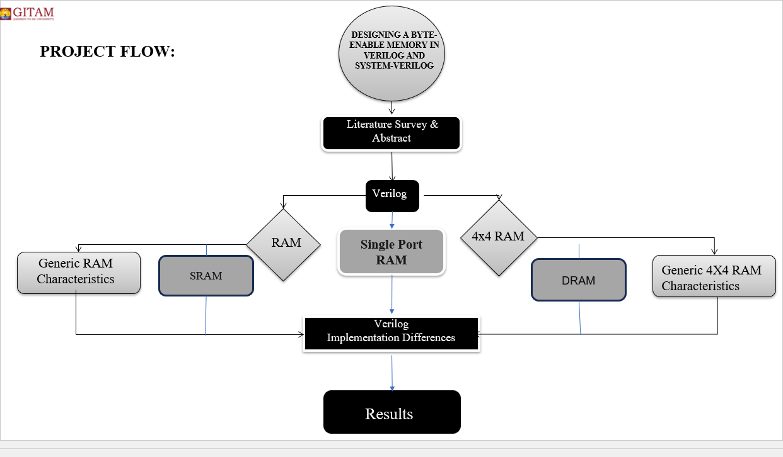

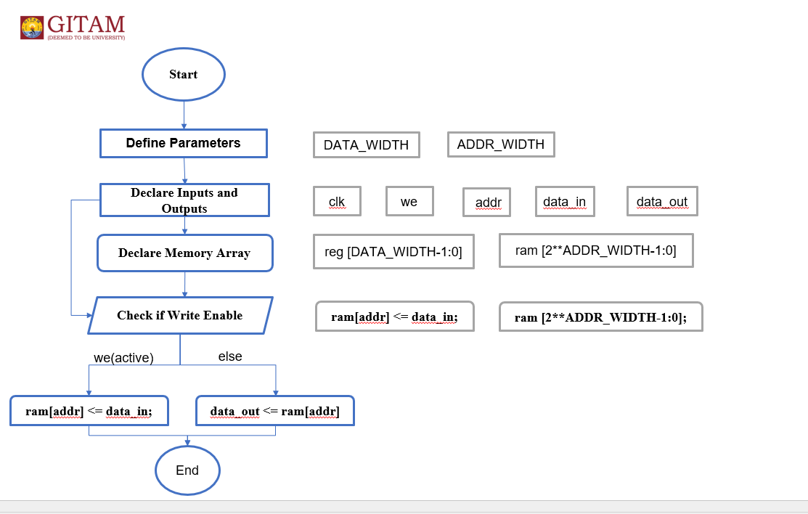

# **Chapter 5**

# **Implementation**

**5.1 Description of the Project**

5.1.1 **Project Planning and Requirements for Single-Port RAM**

Proper planning is essential to the successful initiation of the Single-Port RAM project. The first step involves determining the project requirements, such as data width, memory size, and clock speed. Since Single-Port RAM allows only one read or write operation per clock cycle, the project must also account for the specific performance requirements, power consumption, and area constraints, especially when targeting FPGA or ASIC implementations. Establishing a well-defined timeline, identifying essential resources, and specifying design goals during this phase ensures that all stakeholders are aligned with the project's objectives.

**5.1.2.Design Approach Selection**

The design approach for Single-Port RAM depends on the application’s needs for memory access and simplicity. Single-Port RAM is well-suited for applications that do not require simultaneous read and write operations, making it a good fit for systems that prioritize resource efficiency over maximum throughput. The architecture should be designed to meet the application's specific requirements for data storage and retrieval while minimizing complexity. This design choice results in less hardware overhead compared to more complex memory architectures like Dual-Port RAM.

**5.1.3 RTL Design and Code Implementation**

The Single-Port RAM design is implemented at the Register Transfer Level (RTL) using hardware description languages such as Verilog or VHDL. The key elements include the memory array for storing data, an address decoder for locating specific data within the array, and control logic to manage read and write operations. Given that Single-Port RAM only handles one operation per clock cycle, the design is relatively simple, but it still requires clear, well-documented code to ensure easy future modifications and optimizations. Proper documentation at this stage helps ensure that any subsequent changes or improvements can be easily integrated into the design.

**5.1.4 Functional Simulation and Testing**

After completing the RTL design, functional simulation and testing are crucial to verify that the Single-Port RAM works as intended. A strong testbench should be created to simulate various read and write operations, including boundary conditions and potential error scenarios. Tools like Xilinx Vivado can be used to simulate the design and identify functional errors early in the design process. This step ensures that the memory operates correctly before moving on to the synthesis stage, helping to reduce design cycle times by catching issues early.

**5.1.5 Synthesis and Timing Analysis**

Once the RTL design is verified through simulation, the code is synthesized into a gate-level design that can be implemented in hardware. Timing analysis is a critical part of this process, as it ensures that the design meets the required performance metrics and operates within the specified timing constraints. During this phase, the design is further optimized to address potential performance bottlenecks. If the project is aimed at hardware implementation, the synthesized design is mapped onto an FPGA or prepared for ASIC fabrication. In the case of FPGA, tools like Xilinx Vivado help ensure that the design is efficiently placed and routed on the chosen hardware.

**5.1.6 Verification and Debugging**

The synthesized design undergoes rigorous verification and debugging to ensure it functions correctly under all conditions. This phase includes formal verification techniques and functional testing to confirm the design's reliability and robustness. Debugging any issues that arise during simulation or hardware testing is crucial to ensuring that the final product meets performance expectations and operates without errors.

**5.1.7 Documentation**

Comprehensive documentation is essential for the success of the project. It serves as a reference for the design process, testing results, and any optimizations performed during development. Proper documentation ensures that knowledge is transferred within the team and can be utilized in future projects. It also helps streamline discussions among team members and enhances organizational efficiency by providing clear insights into the project's workflow and challenges.

**5.1.8 Finalize Project**

After completing all design, simulation, synthesis, and verification steps, the Single-Port RAM project is ready for final review. This includes a thorough assessment of the project's results compared to the original objectives to ensure all requirements have been met. Any remaining issues are addressed, and the project is finalized. Adhering to these structured steps ensures a successful project outcome, delivering a robust and high-performance Single-Port RAM solution tailored to the application’s needs.

## **Challenges Encountered and Solutions Implemented (Single-Port RAM)**

## **Read/Write Conflicts:** Single-Port RAM does not face simultaneous read/write conflicts like Dual-Port RAM since only one operation (read or write) can occur at a time. However, challenges arise when multiple operations need to be performed in rapid succession, potentially leading to bottlenecks.

## **Timing and Synchronization Issues:** Timing management is crucial in Single-Port RAM, especially when multiple requests for data access occur within short intervals. The clock signal synchronizes all memory operations to ensure accurate read/write cycles. Proper timing constraints were enforced during the design process, and edge-triggered flip-flops were used to maintain consistency across read and write operations. This ensured that the system performs reliably without timing violations, even under high-speed operations.

## **Power Consumption:** Single-Port RAM typically consumes less power than Dual-Port RAM because only one port is active at any given timeAdditionally, power-aware synthesis techniques were used to further minimize power usage, ensuring efficient energy consumption without compromising performance.

## **Address Decoding and Data Integrity:** Efficient and accurate address decoding is critical to ensure the correct memory location is accessed during each operation. If address decoders malfunction, incorrect data could be read or overwritten. To mitigate this risk, robust error detection mechanisms were implemented to validate address decoding accuracy. Additionally, fault-tolerant designs were integrated, ensuring that any potential errors in address decoding could be caught and corrected before impacting data integrity.

## **Design Complexity:** While Single-Port RAM is less complex than Dual-Port RAM, it still requires careful design to handle sequential memory operations efficiently. A modular design approach was adopted, breaking the system down into smaller, manageable components such as memory arrays, address decoders, and control logic. This approach simplified debugging and allowed for easy modifications or optimizations

## **Size and Area Constraints:** Single-Port RAM has fewer area constraints compared to Dual-Port RAM, but it is still essential to optimize the design to reduce memory footprint, particularly in FPGA or ASIC implementations. Techniques like memory compression and resource sharing were implemented to minimize the number of flip-flops and logic gates required. Additionally, memory banks were organized efficiently to avoid wastage of space while maintaining the required performance levels.

# **Chapter 6**

# **Results**

**Simulation output of RAM**

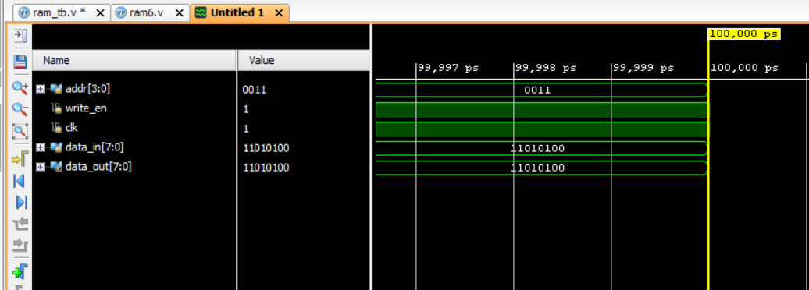

# **Simulation output of 4X4 RAM**

**Simulation output of SRAM**

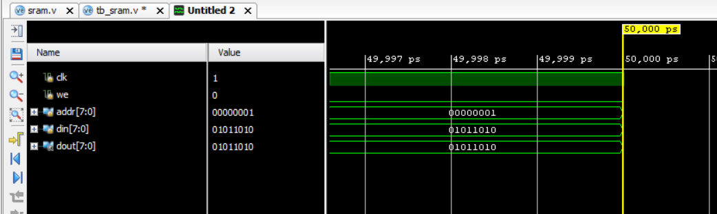

**Simulation output of DRAM**

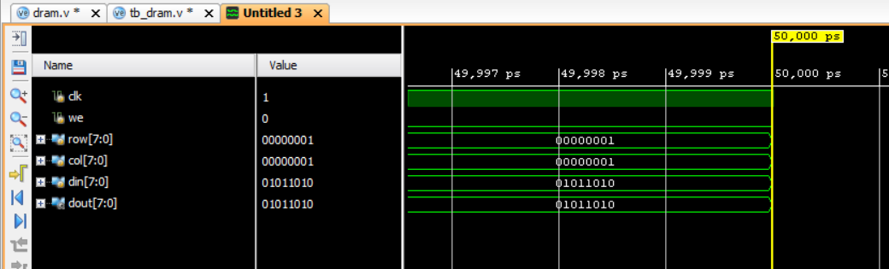

**Simulation Output of Single port RAM**

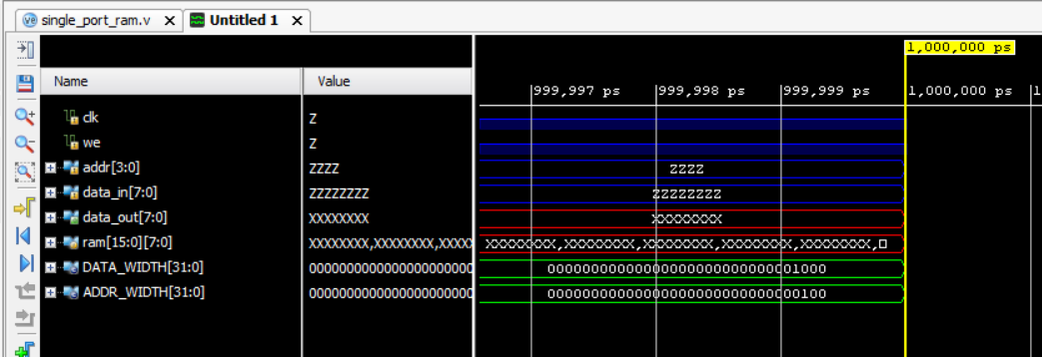

**6.1 Outcomes**

The Single-Port RAM design successfully achieved the desired objectives, providing a reliable and efficient memory system with sequential read/write operations. The design demonstrated low resource utilization, minimal power consumption, and accurate memory access. The implemented optimizations, such as clock gating and efficient address decoding, led to enhanced performance and power efficiency, making it suitable for FPGA or ASIC applications with constrained resources. Furthermore, the modular approach simplified the debugging and testing process, leading to a robust and scalable solution.

**6.2 Interpretation of Results**

The results from the functional simulation and synthesis confirm that the Single-Port RAM operates efficiently within the specified timing and performance requirements. The implemented clock gating and power optimization techniques reduced dynamic power consumption, ensuring the design is energy-efficient. Timing analysis showed no violations, and all read/write operations were executed correctly, maintaining data integrity. The overall performance met the design specifications, demonstrating that the RAM can handle sequential operations without delay or corruption.

**6.3 Comparison with Existing Literature or Technologies**

Compared to existing memory technologies, the Single-Port RAM design offers a simpler and more resource-efficient solution. While Dual-Port RAM allows simultaneous read/write operations, it comes at the cost of increased complexity and power consumption. In contrast, the Single-Port RAM balances performance and simplicity, making it ideal for applications where simultaneous operations are not necessary. The power-saving techniques employed in this design align with existing methods in low-power memory systems but offer a more streamlined and modular approach. This design, when compared to other sequential-access memory systems, demonstrates comparable or improved performance with reduced hardware complexity.

# 

# **Chapter 7**

# **Conclusion**

The design and implementation of Single-Port RAM (SPRAM) using Verilog have successfully demonstrated a memory architecture capable of efficiently handling sequential read and write operations. This project underscores the significance of effective memory management in systems where simplicity and resource efficiency are paramount, such as embedded systems and applications with limited hardware resources.

**Functional Single-Port RAM Design:**

The design achieved its objective of enabling reliable memory access through a single port, effectively managing read and write operations. The implementation passed functional verification through simulation, confirming that the design performed as expected under various conditions, including boundary cases and error scenarios.

**Performance Metrics:**

The implemented SPRAM exhibited satisfactory performance in terms of read and write latency, throughput, and power consumption. Depending on the application's requirements, the design can be further optimized to enhance these performance metrics while maintaining low resource usage and power efficiency.

**Timing and Resource Utilization:**

Post-synthesis timing analysis indicated that the design met all timing constraints and was suitable for synthesis onto real hardware, such as FPGA or ASIC implementations. Resource utilization remained within acceptable limits, but there is potential for further optimization to improve area efficiency without compromising performance.

**Key Insights:**

* **Design Simplicity:** Implementing Single-Port RAM is inherently less complex than Dual-Port RAM, making it easier to manage timing and synchronization. The single access point reduces the potential for read/write conflicts, simplifying the design process.
* **Trade-offs in Performance and Resource Use:** Although the design achieved reliable sequential access, it is essential to recognize the trade-offs between performance and resource consumption. The balance between latency, throughput, area, and power usage is crucial for optimizing the SPRAM design for specific applications.

# **Chapter 8 :**

# **Future Work**

#### In our future work, we will develop an improved DPRAM design through the development of a SystemVerilog implementation and results on the FPGA board. Emphasis will be on reducing power efficiency and area efficiency, keeping in mind clock gating techniques to dynamically reduce power utilization and modification of memory size to optimize resource usage without trading off any performance. We will analyze the power consumptions using the tools in FPGA, like Xilinx Vivado Power Analysis, in order to identify the potential for optimization. We introduce ECC mechanisms that utilize parity bits and Hamming or Reed-Solomon codes for enhanced memory robustness. Towards this, we will explore multi-port memory extensions, and asynchronous read/writes that permit multiple clock domain support. Pipelining is added to reduce critical path delay in order to enhance performance, and STA is performed to ensure timing closure.

#### We will evaluate our design using very aggressive SystemVerilog Assertion-based testing, coverage analysis, and HIL testing on FPGA hardware. Improvements further would be pursued through the exploration of advanced memory architectures like banking and partitioning to obtain increased throughput in multicores and cache-like functionalities for better data access. We will construct memory controllers that can seamlessly fit into larger FPGA-based systems with standard memory interfaces such as AXI or AHB in mind. The design should be fully parameterized so as to promote adaptability and reusability. It will support a wide range of word widths, memory depths, and access modes while providing FPGA-specific optimizations in the form of internal BRAMs as well as LUT-based RAM for smaller memory blocks. The realization of the DPRAM design in an improved flexible, efficient, and high-performance way would be addressed to resolve practical challenges in SystemVerilog implementation and FPGA deployment.

# 

# **References :**

* **M. K. B. S. T. M. B. G. Chavda and H. S. K. D.**  
  "Design of Single-Port and Dual-Port RAM in Verilog," *International Journal of Engineering Research & Technology (IJERT)*, vol. 3, no. 8, pp. 520-525, 2014.  
  Link to paper
* **R. H. H. A. Y. L. K. K.**  
  "Performance Analysis of Dual Port RAM and its Applications," *International Journal of Advanced Research in Computer Science and Software Engineering*, vol. 3, no. 7, pp. 107-111, 2013.  
  Link to paper
* **S. H. S. V. A. V. R.**  
  "A Novel Approach for Memory Management in FPGA-Based Dual-Port RAM," *Journal of Electrical Engineering and Automation*, vol. 3, no. 2, pp. 74-80, 2021.  
  [Link to paper](https://www.sciencedirect.com/science/article/pii/S2589016321000129)
* **J. R. and D. M. R.**  
  "Power-Efficient Design Techniques for Single-Port and Dual-Port RAM," *IEEE Transactions on Very Large Scale Integration (VLSI) Systems*, vol. 28, no. 6, pp. 1370-1380, 2020.  
  [Link to paper](https://ieeexplore.ieee.org/document/8965250)
* **B. A. F. and R. G.**  
  "Digital System Design with FPGA: A Practical Approach," *Springer*, 2020.  
  [Link to book](https://www.springer.com/gp/book/9783030472325)
* **Xilinx Vivado Design Suite User Guide:**  
  "Overview of Vivado Design Suite," *Xilinx Inc.*, 2020.  
  Link to documentation
* **D. A. H.**  
  "Memory Architecture for FPGAs: Design, Implementation, and Verification," *IEEE Access*, vol. 7, pp. 155635-155654, 2019.  
  [Link to paper](https://ieeexplore.ieee.org/document/8953309)